Assignment - 3
Course Number - ACS-2913-001
Course Name - Software Requirements Analysis and Design
Instructor – Victor Balogun
Students Name - Manmeet Singh [ St id- 3177236]
Daljeet Singh [ St id- 3169763]

- USE CASE DESCRIPTIONS:

Use Case Name: | Create Learner account
Scenario: | Create learner account
Triggering Event: | New Learner wants to set up the account.
Brief Description: | Learner creates account by giving basic information, followed up by entering address and contact details.
Actors: | Learner
Related Use Cases: | Might be invoked by the Subscription use case.
Stakeholders: | Accounting, Marketing, Database Administrator.
Preconditions: | Learner account subsystem must be available.  Contact details must be available.
Postconditions: | Learner must be created and saved.  Addresses must be saved.  Contact details must be validated.  Learner account must be created and saved.  Address and contact details must be related to customers.
Flow of activities: | Actor | System
 | - Learner enters basic details in order to create customer account.  - Learner enters one or more addresses.  - Learner enters contact details. | 1.1 System creates a new customer. 1.2 System prompts for customer addresses.  2.1 System create addresses.  2.2 System prompts for contact details.  3.1s System creates account.  3.2s System verifies contact details.  3.3s System associates customer, address, and account.
Exception Conditions: | - Basic Information of customer is incomplete.  2.1 The address is not appropriate.  3.2 Contact Details are not correct.

Use Case Name: | Language Lesson
Scenario: | Provides language lessons to the learner as per his or her requirement.
Triggering Event: | Learner selects a language lesson from the available list in the system.
Brief Description: | Learner choose the language and the system provides language lesson and then learner provides feedback , system keeps record and adjust level as per feedback.
Actors: | Learner
Related Use Cases: | Might be pronunciation practice use case
Stakeholders: | Development team, language experts
Preconditions: | Learner has created the account and logged in.  Language lessons must be available for the selected language.
Postconditions: | Learner completed the lesson.  Feedback is provided and it must be recorded.  System must adjust lesson tutoring as per feedback.
Flow of activities: | Actor | System
 | - Learner selects the language.  - Learner start lesson and interact with it.  - Learner gives the feedback. | 1.1 System present the selected language.  1.2 System prompts for start session.  2.1 System load the content for the language lesson and process interaction.  - System prompts for the feedback.  3.1 System keep record of the feedback.  3.2 System updates user progress and adjust lesson tutoring as per feedback.
Exception Conditions: | - Language is not available.  2.2 System not able to load the content due to loss connection.  3.2 System not able to adjust the lesson due to improper feedback.

- Activity Diagrams
- Create Learner Account

Learner | System
Request Account  Enter Addresses  Enter Contact Details | Return Account Details  Create account  Validate contact details,  Create addresses  Create learner

- Language Lesson

Learner | System
Select Language  Start Session  Interact with lesson  Give feedback | Updates user’s progress and make adjustment in the language tutoring as per feedback.  Process interaction  Saved the Feedback  Present selected language  Load the content

- System Sequence Diagrams

- Create Customer Account
:System

Learner

createNewLearner(name,DOB,gender)

learner id, name, dob, gender

*address details := enterAddress(address)

enterContact(contact-info)

contact info details

:System

Learner

selectLanguage(language)

present language

startLesson

content

giveFeedback(feedback)

feedback details

user’s progress and lesson tutoring updated

- Language Lesson

4. First Cut Design Class Diagram:

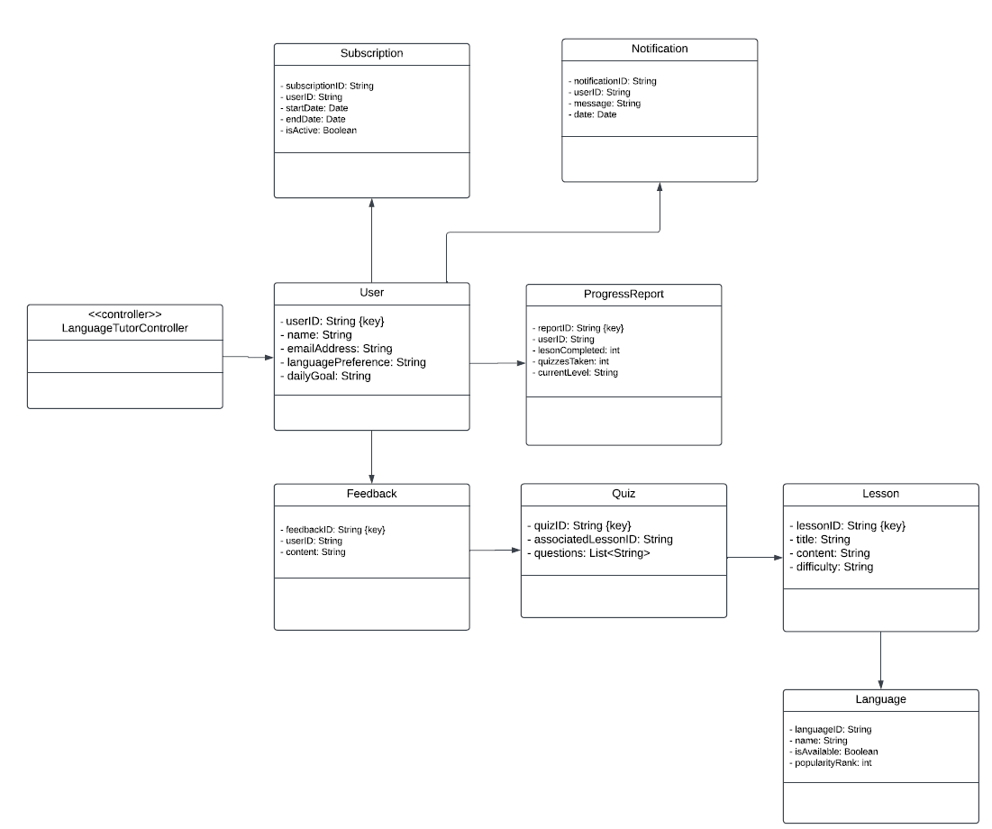

5. (a) CRC Cards:
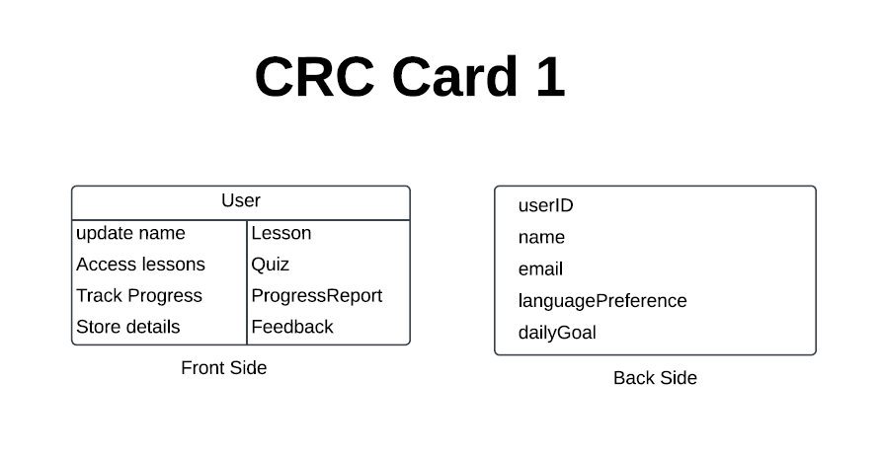
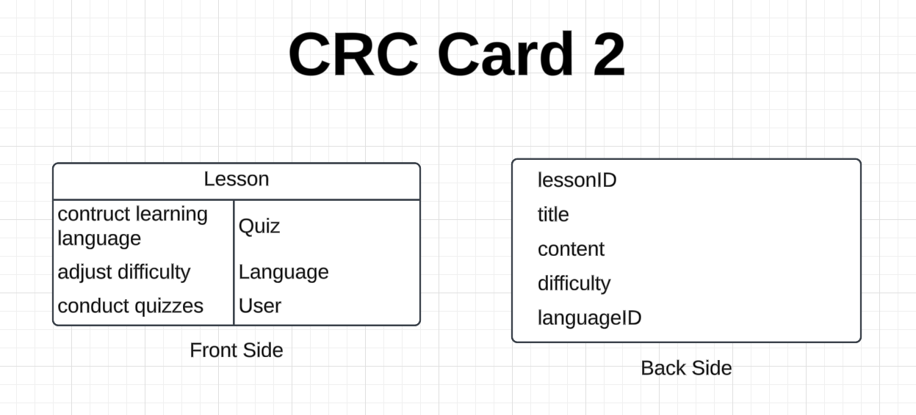

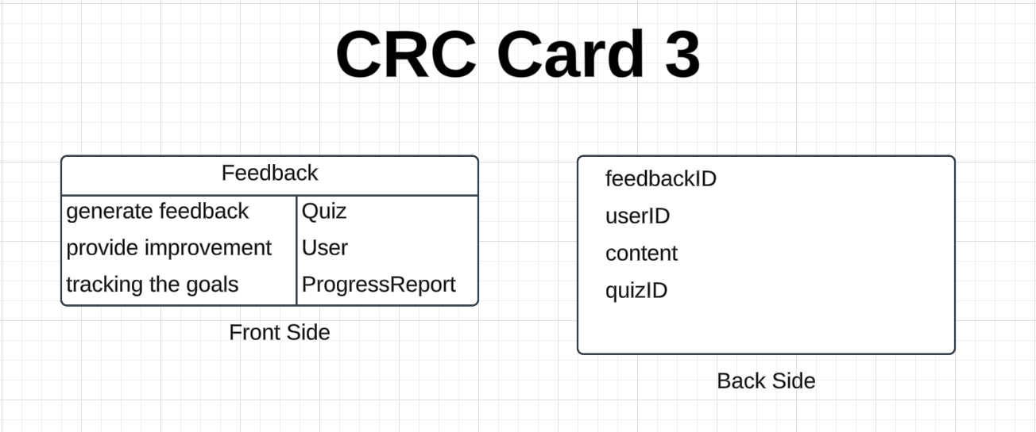

(b) SEQUENCE DIAGRAM:
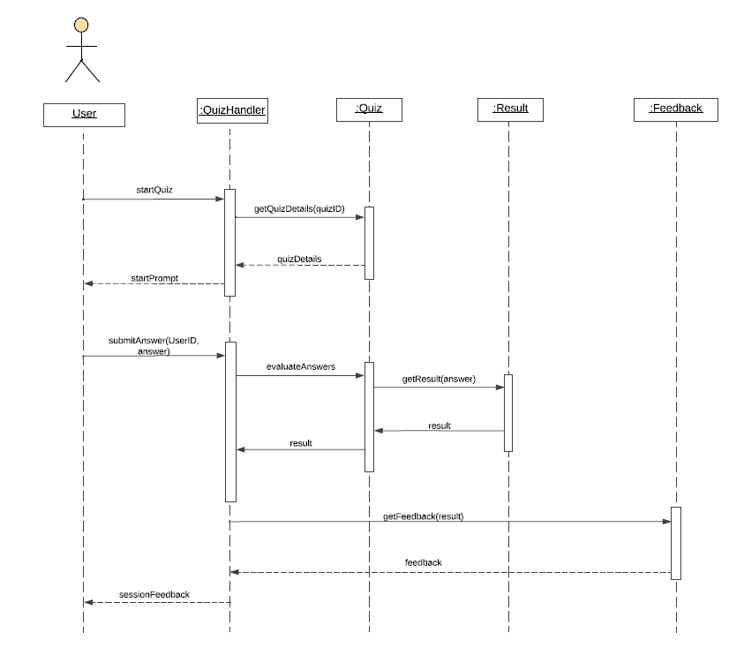

(c) COMMUNICATION DIAGRAM:
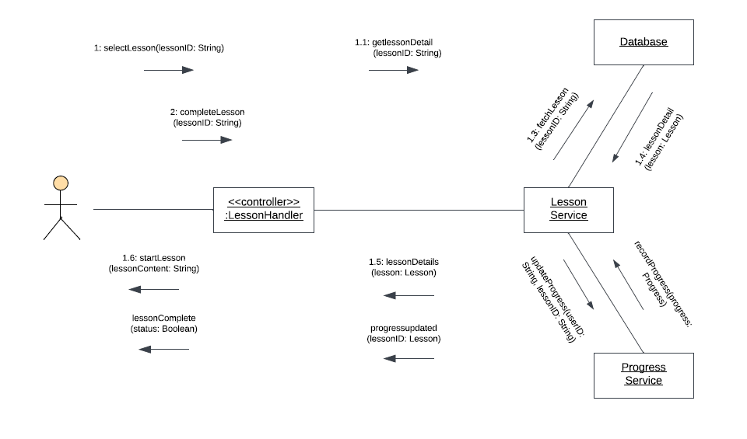

6. DESIGN CLASS DIAGRAM:

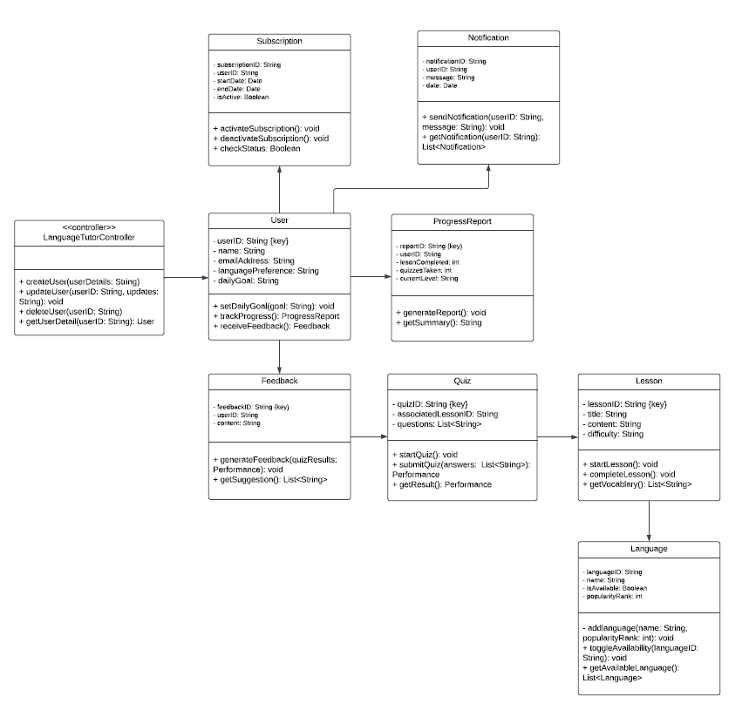

7. CLASS PACKAGE DIAGRAM:
